**Speaker Biographies:**

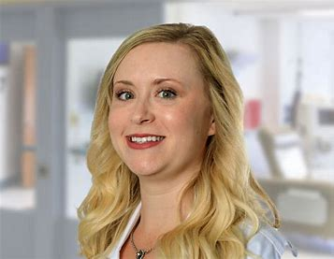**Alycia Coutts, MSN, RN, FNP-C**  
Alycia Coutts, MSN, RN, FNP-C, is a board-certified nurse practitioner and currently the lead Nurse Practitioner at Trinity ENT. She has been in ENT for just over five and a half years and also occasionally provides care at the First Care Walk-in Clinic. She is the current President of the Advanced Practice Provider Executive Committee at Trinity Health and is actively involved in the PNO committee. She has a special interest in all things ears and otology! She has worked alongside surgeons with extensive experience in mastoid and tympanoplasty procedures. She also coordinates closely with the otologists across the state to manage care for patients. Alycia enjoys working with her audiology partners for holistic patient care, including children with hearing loss.

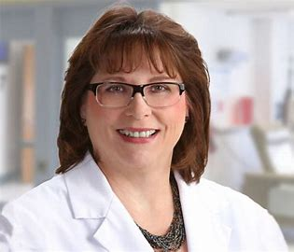**Anne Welch, FNP**  
Anne Welch, FNP-C, is a board-certified family nurse practitioner and a member of Trinity’s Dermatology team. She is a graduate of Minot State University’s nursing program and earned her Master of Science/Family Nurse Practitioner degree and a master’s in Case Management, both from the University of Mary in Bismarck. She has been in health care since 1978, starting as a nurse's aide, and has worked through the ranks. She enjoys teaching and precepting students, believing that knowledge is meant to be shared! She has worked in OB/GYN at St. Joe’s, long-term care in Garrison and Manor Care, and previously in the medical-surgical unit at Minot Air Force Base and in case management for BlueCross and Blue Shield.

**Aggie Kennedy, AuD, CCC-A**  
Aggie Kennedy is a clinical specialist in the Great Lakes region at Advanced Bionics, LLC. Prior to joining AB, Dr. Kennedy worked at The University of South Dakota as a clinical instructor while supporting the cochlear implant clinic and at a private practice ear, nose, and throat clinic. Dr. Kennedy received her Doctorate of Audiology at the University of South Dakota. She currently resides in southeastern South Dakota.

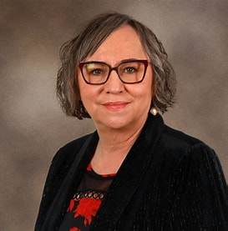**Annette Mennem**  
Annette Mennem is the Director of the Native American Center at Minot State University (MSU) and is a two-time alumna of MSU. Her role is to recruit, retain, and graduate Native American students; beyond that, she advocates for them. She serves as a liaison with area tribes and tribal colleges to maintain close working relationships with MSU.Annette has spent the last 30 years working with diverse populations—teaching at tribal nation schools, through the Job Corps program, and at Minot State University. Annette is an enrolled member of the Turtle Mountain Band of Ojibwe.

**Dr. Katrina Fulcher-Rood, CCC-SLP, BCS-CL**   
Dr. Katrina Fulcher-Rood, CCC-SLP, BCS-CL, has been a practicing, licensed, and certified speech-language pathologist since 2011. Board-certified with expertise in child language and language disorders, she earned a Ph.D. in Communication Disorders and Sciences in 2014. Her peer-reviewed journal articles have been published in numerous academic and scientific journals, and she was recently applauded by *The New York Times*. Katrina Fulcher-Rood grew up in Lockport, NY.

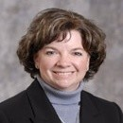**Gretchen Flynn**   
Gretchen Flynn is the Senior Cochlear Implant Consumer Specialist for Advanced Bionics for Minnesota, North Dakota, and South Dakota. Gretchen’s role is to work with CI candidates and recipients, helping them navigate the cochlear implant process. She is also responsible for outreach and education in the community, educating hearing care professionals on hearing healthcare and cochlear implants. Before joining AB in 2019, Gretchen worked in Human Resources. She earned her bachelor’s degree from the College of St. Benedict and is a Certified HR Professional.

**Julia Bidenstein, MS**   
Julia Biedenstein, MS, has been a Cochlear Implant Consumer Specialist with Advanced Bionics for 11 years. Prior to coming to AB, she was a Listening and Spoken Language Specialist (LSLS cert AVEd) serving as a classroom teacher and school administrator at Central Institute for the Deaf and the Moog Center for Deaf Education, and as a researcher at Washington University, studying speech and language outcomes in children with cochlear implants. She has done extensive aural (re)habilitation with both children and adults and has co-authored 3 widely used curricula for deaf children: SPICE: Speech Perception Instructional Curriculum and Evaluation; TASL: Teacher Assessment of Spoken Language; and Teaching Activities for Children Who are Deaf and Hard of Hearing.

**Jessica A. Ballard, Au.D, CCC-A**

Jessica Ballard, Au.D., joined Cochlear in 2009 and currently holds the position of Clinical Technical Project Manager. Jessica is responsible for training professionals on clinical and surgical aspects of Cochlear’s implantable hearing solution portfolio. Jessica also supports complicated surgical and clinical cases, as well as new product launches. Jessica received her undergraduate training in Communication Disorders from Eastern Washington University and obtained a Doctor of Audiology degree from the University of Oklahoma Health Sciences Center. Following completion of her education, Jessica worked as a CI Audiologist at Hearts for Hearing in Oklahoma City serving both pediatrics and adults.

**Sarah Almquist, AuD**   
Sarah Almquist, Au.D., is a licensed audiologist with a clinical doctorate from the University of Minnesota.  Sarah has been with Cochlear since 2017 and currently manages the Northern and Central Plains territories.

**Sarah Ring, CCC-SLP**  
Sarah Ring is a Senior Therapist in the Speech-Language Pathology Department at Sanford Health Fargo, where she has provided cognitive, communication, and dysphagia services for nearly 28 years. Sarah has a special interest in acquired brain injury rehabilitation and concussion management across pediatric, adolescent, and adult populations. Sarah earned the designation of Certified Brain Injury Specialist Trainer from the Brain Injury Association of America in 2019 and was awarded Certified Brain Injury Specialist of the Year (2021) by the North Dakota Brain Injury Network. Sarah is an active board member of the governor-appointed North Dakota Brain Injury Advisory Council and serves as an adjunct professor in the Department of Speech, Language, and Hearing Sciences at Minnesota State University-Moorhead.